GITHUB

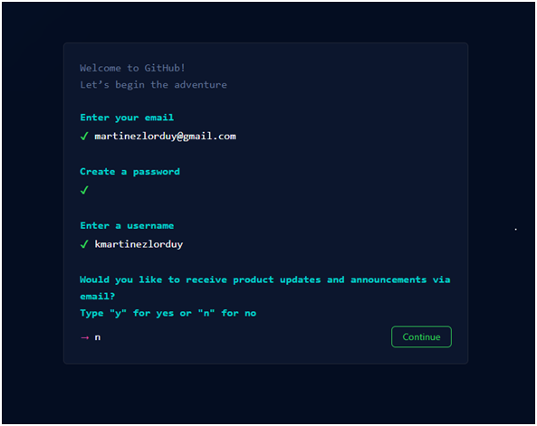

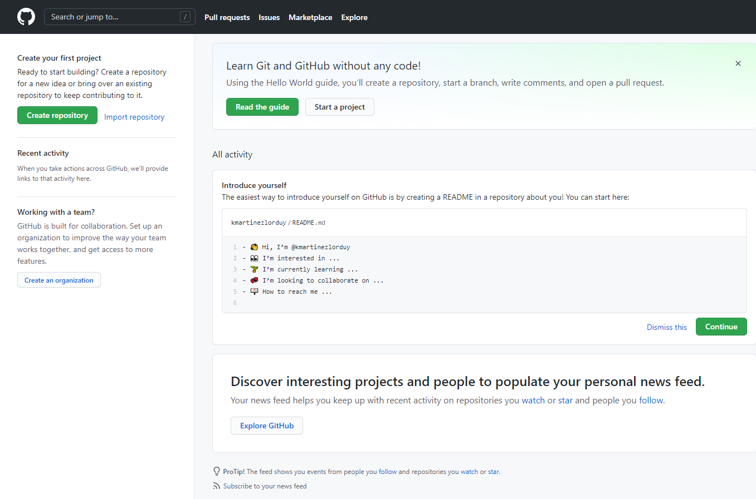

Sammy@SCABRERA-LENOVO MINGW64 /f/git

$ mkdir github

Sammy@SCABRERA-LENOVO MINGW64 /f/git

$ cd github

Sammy@SCABRERA-LENOVO MINGW64 /f/git/github

$ mkdir kmartinezlorduy

Sammy@SCABRERA-LENOVO MINGW64 /f/git/github

$ cd kmartinezlorduy

Sammy@SCABRERA-LENOVO MINGW64 /f/git/github/kmartinezlorduy

$ cd KTEventos

Sammy@SCABRERA-LENOVO MINGW64 /f/git/github/kmartinezlorduy/KTEventos

$ dir

assets css nosotros.html

Cambios\ SEO.txt index.html servicios.html

contacto.html js workspace.code-workspace

Sammy@SCABRERA-LENOVO MINGW64 /f/git/github/kmartinezlorduy/KTEventos

$ dir

assets css nosotros.html

Cambios\ SEO.txt index.html servicios.html

contacto.html js workspace.code-workspace

Sammy@SCABRERA-LENOVO MINGW64 /f/git/github/kmartinezlorduy/KTEventos

$ git status

fatal: Not a git repository (or any of the parent directories): .git

Sammy@SCABRERA-LENOVO MINGW64 /f/git/github/kmartinezlorduy/KTEventos

$ git init

Initialized empty Git repository in F:/GIT/github/kmartinezlorduy/KTEventos/.git/

Sammy@SCABRERA-LENOVO MINGW64 /f/git/github/kmartinezlorduy/KTEventos (master)

$ git status

On branch master

Initial commit

Untracked files:

(use "git add <file>..." to include in what will be committed)

Cambios SEO.txt

assets/

contacto.html

css/

index.html

js/

nosotros.html

servicios.html

workspace.code-workspace

nothing added to commit but untracked files present (use "git add" to track)

Sammy@SCABRERA-LENOVO MINGW64 /f/git/github/kmartinezlorduy/KTEventos (master)

$ git add .

warning: LF will be replaced by CRLF in css/bootstrap-grid.css.

The file will have its original line endings in your working directory.

warning: LF will be replaced by CRLF in css/bootstrap-grid.min.css.

The file will have its original line endings in your working directory.

warning: LF will be replaced by CRLF in css/bootstrap-grid.rtl.css.

The file will have its original line endings in your working directory.

warning: LF will be replaced by CRLF in css/bootstrap-grid.rtl.min.css.

The file will have its original line endings in your working directory.

warning: LF will be replaced by CRLF in css/bootstrap-reboot.css.

The file will have its original line endings in your working directory.

warning: LF will be replaced by CRLF in css/bootstrap-reboot.min.css.

The file will have its original line endings in your working directory.

warning: LF will be replaced by CRLF in css/bootstrap-reboot.rtl.css.

The file will have its original line endings in your working directory.

warning: LF will be replaced by CRLF in css/bootstrap-reboot.rtl.min.css.

The file will have its original line endings in your working directory.

warning: LF will be replaced by CRLF in css/bootstrap-utilities.css.

The file will have its original line endings in your working directory.

warning: LF will be replaced by CRLF in css/bootstrap-utilities.min.css.

The file will have its original line endings in your working directory.

warning: LF will be replaced by CRLF in css/bootstrap-utilities.rtl.css.

The file will have its original line endings in your working directory.

warning: LF will be replaced by CRLF in css/bootstrap-utilities.rtl.min.css.

The file will have its original line endings in your working directory.

warning: LF will be replaced by CRLF in css/bootstrap.css.

The file will have its original line endings in your working directory.

warning: LF will be replaced by CRLF in css/bootstrap.min.css.

The file will have its original line endings in your working directory.

warning: LF will be replaced by CRLF in css/bootstrap.rtl.css.

The file will have its original line endings in your working directory.

warning: LF will be replaced by CRLF in css/bootstrap.rtl.min.css.

The file will have its original line endings in your working directory.

warning: LF will be replaced by CRLF in css/contact.css.

The file will have its original line endings in your working directory.

warning: LF will be replaced by CRLF in css/contact.css.map.

The file will have its original line endings in your working directory.

warning: LF will be replaced by CRLF in css/contact.min.css.

The file will have its original line endings in your working directory.

warning: LF will be replaced by CRLF in css/contact.min.css.map.

The file will have its original line endings in your working directory.

warning: LF will be replaced by CRLF in css/estilos.css.

The file will have its original line endings in your working directory.

warning: LF will be replaced by CRLF in css/estilos.css.map.

The file will have its original line endings in your working directory.

warning: LF will be replaced by CRLF in css/estilos.min.css.

The file will have its original line endings in your working directory.

warning: LF will be replaced by CRLF in css/estilos.min.css.map.

The file will have its original line endings in your working directory.

warning: LF will be replaced by CRLF in css/font-awesome.css.

The file will have its original line endings in your working directory.

warning: LF will be replaced by CRLF in css/font-awesome.min.css.

The file will have its original line endings in your working directory.

warning: LF will be replaced by CRLF in css/normalize.css.

The file will have its original line endings in your working directory.

warning: LF will be replaced by CRLF in css/styles.css.

The file will have its original line endings in your working directory.

warning: LF will be replaced by CRLF in index.html.

The file will have its original line endings in your working directory.

warning: LF will be replaced by CRLF in js/bootstrap.bundle.js.

The file will have its original line endings in your working directory.

warning: LF will be replaced by CRLF in js/bootstrap.bundle.min.js.

The file will have its original line endings in your working directory.

warning: LF will be replaced by CRLF in js/bootstrap.esm.js.

The file will have its original line endings in your working directory.

warning: LF will be replaced by CRLF in js/bootstrap.esm.min.js.

The file will have its original line endings in your working directory.

warning: LF will be replaced by CRLF in js/bootstrap.js.

The file will have its original line endings in your working directory.

warning: LF will be replaced by CRLF in js/bootstrap.min.js.

The file will have its original line endings in your working directory.

warning: LF will be replaced by CRLF in js/scripts.js.

The file will have its original line endings in your working directory.

warning: LF will be replaced by CRLF in workspace.code-workspace.

The file will have its original line endings in your working directory.

Sammy@SCABRERA-LENOVO MINGW64 /f/git/github/kmartinezlorduy/KTEventos (master)

$ git status

On branch master

Initial commit

Changes to be committed:

(use "git rm --cached <file>..." to unstage)

new file: Cambios SEO.txt

new file: assets/boda.jpg

new file: assets/construir-un-equipo-de-trabajo-1.png

new file: assets/cumpleanos.JPG

new file: assets/equipo-audio.jpg

new file: assets/equipo-cocina.jpg

new file: assets/equipo-logistica.jpg

new file: assets/facebook.png

new file: assets/favicon.ico

new file: assets/img1.png

new file: assets/img2.png

new file: assets/instagram.png

new file: assets/kathe.jpg

new file: assets/linkedin.png

new file: assets/matrimonios-home.jpg

new file: assets/negocios.jpg

new file: assets/quienessomos.jpg

new file: assets/service-babyshower.jpg

new file: assets/service-boda.jpg

new file: assets/service-cumpleanos.jpg

new file: assets/service-despedida.jpg

new file: assets/service-empresarial.jpg

new file: assets/service-quince.jpg

new file: assets/whatsapp.png

new file: contacto.html

new file: css/banner.css

new file: css/bootstrap-grid.css

new file: css/bootstrap-grid.css.map

new file: css/bootstrap-grid.min.css

new file: css/bootstrap-grid.min.css.map

new file: css/bootstrap-grid.rtl.css

new file: css/bootstrap-grid.rtl.css.map

new file: css/bootstrap-grid.rtl.min.css

new file: css/bootstrap-grid.rtl.min.css.map

new file: css/bootstrap-reboot.css

new file: css/bootstrap-reboot.css.map

new file: css/bootstrap-reboot.min.css

new file: css/bootstrap-reboot.min.css.map

new file: css/bootstrap-reboot.rtl.css

new file: css/bootstrap-reboot.rtl.css.map

new file: css/bootstrap-reboot.rtl.min.css

new file: css/bootstrap-reboot.rtl.min.css.map

new file: css/bootstrap-utilities.css

new file: css/bootstrap-utilities.css.map

new file: css/bootstrap-utilities.min.css

new file: css/bootstrap-utilities.min.css.map

new file: css/bootstrap-utilities.rtl.css

new file: css/bootstrap-utilities.rtl.css.map

new file: css/bootstrap-utilities.rtl.min.css

new file: css/bootstrap-utilities.rtl.min.css.map

new file: css/bootstrap.css

new file: css/bootstrap.css.map

new file: css/bootstrap.min.css

new file: css/bootstrap.min.css.map

new file: css/bootstrap.rtl.css

new file: css/bootstrap.rtl.css.map

new file: css/bootstrap.rtl.min.css

new file: css/bootstrap.rtl.min.css.map

new file: css/contact.css

new file: css/contact.css.map

new file: css/contact.min.css

new file: css/contact.min.css.map

new file: css/estilos.css

new file: css/estilos.css.map

new file: css/estilos.min.css

new file: css/estilos.min.css.map

new file: css/font-awesome.css

new file: css/font-awesome.min.css

new file: css/normalize.css

new file: css/sass/base/_colores.scss

new file: css/sass/base/_fuentes.scss

new file: css/sass/base/_mixins.scss

new file: css/sass/contact.scss

new file: css/sass/estilos.scss

new file: css/styles.css

new file: index.html

new file: js/banner.js

new file: js/bootstrap.bundle.js

new file: js/bootstrap.bundle.js.map

new file: js/bootstrap.bundle.min.js

new file: js/bootstrap.bundle.min.js.map

new file: js/bootstrap.esm.js

new file: js/bootstrap.esm.js.map

new file: js/bootstrap.esm.min.js

new file: js/bootstrap.esm.min.js.map

new file: js/bootstrap.js

new file: js/bootstrap.js.map

new file: js/bootstrap.min.js

new file: js/bootstrap.min.js.map

new file: js/scripts.js

new file: nosotros.html

new file: servicios.html

new file: workspace.code-workspace

Sammy@SCABRERA-LENOVO MINGW64 /f/git/github/kmartinezlorduy/KTEventos (master)

$ git commit -m "First commit"

[master (root-commit) 1b3f7c4] First commit

warning: LF will be replaced by CRLF in css/bootstrap-grid.css.

The file will have its original line endings in your working directory.

warning: LF will be replaced by CRLF in css/bootstrap-grid.min.css.

The file will have its original line endings in your working directory.

warning: LF will be replaced by CRLF in css/bootstrap-grid.rtl.css.

The file will have its original line endings in your working directory.

warning: LF will be replaced by CRLF in css/bootstrap-grid.rtl.min.css.

The file will have its original line endings in your working directory.

warning: LF will be replaced by CRLF in css/bootstrap-reboot.css.

The file will have its original line endings in your working directory.

warning: LF will be replaced by CRLF in css/bootstrap-reboot.min.css.

The file will have its original line endings in your working directory.

warning: LF will be replaced by CRLF in css/bootstrap-reboot.rtl.css.

The file will have its original line endings in your working directory.

warning: LF will be replaced by CRLF in css/bootstrap-reboot.rtl.min.css.

The file will have its original line endings in your working directory.

warning: LF will be replaced by CRLF in css/bootstrap-utilities.css.

The file will have its original line endings in your working directory.

warning: LF will be replaced by CRLF in css/bootstrap-utilities.min.css.

The file will have its original line endings in your working directory.

warning: LF will be replaced by CRLF in css/bootstrap-utilities.rtl.css.

The file will have its original line endings in your working directory.

warning: LF will be replaced by CRLF in css/bootstrap-utilities.rtl.min.css.

The file will have its original line endings in your working directory.

warning: LF will be replaced by CRLF in css/bootstrap.css.

The file will have its original line endings in your working directory.

warning: LF will be replaced by CRLF in css/bootstrap.min.css.

The file will have its original line endings in your working directory.

warning: LF will be replaced by CRLF in css/bootstrap.rtl.css.

The file will have its original line endings in your working directory.

warning: LF will be replaced by CRLF in css/bootstrap.rtl.min.css.

The file will have its original line endings in your working directory.

warning: LF will be replaced by CRLF in css/contact.css.

The file will have its original line endings in your working directory.

warning: LF will be replaced by CRLF in css/contact.css.map.

The file will have its original line endings in your working directory.

warning: LF will be replaced by CRLF in css/contact.min.css.

The file will have its original line endings in your working directory.

warning: LF will be replaced by CRLF in css/contact.min.css.map.

The file will have its original line endings in your working directory.

warning: LF will be replaced by CRLF in css/estilos.css.

The file will have its original line endings in your working directory.

warning: LF will be replaced by CRLF in css/estilos.css.map.

The file will have its original line endings in your working directory.

warning: LF will be replaced by CRLF in css/estilos.min.css.

The file will have its original line endings in your working directory.

warning: LF will be replaced by CRLF in css/estilos.min.css.map.

The file will have its original line endings in your working directory.

warning: LF will be replaced by CRLF in css/font-awesome.css.

The file will have its original line endings in your working directory.

warning: LF will be replaced by CRLF in css/font-awesome.min.css.

The file will have its original line endings in your working directory.

warning: LF will be replaced by CRLF in css/normalize.css.

The file will have its original line endings in your working directory.

warning: LF will be replaced by CRLF in css/styles.css.

The file will have its original line endings in your working directory.

warning: LF will be replaced by CRLF in index.html.

The file will have its original line endings in your working directory.

warning: LF will be replaced by CRLF in js/bootstrap.bundle.js.

The file will have its original line endings in your working directory.

warning: LF will be replaced by CRLF in js/bootstrap.bundle.min.js.

The file will have its original line endings in your working directory.

warning: LF will be replaced by CRLF in js/bootstrap.esm.js.

The file will have its original line endings in your working directory.

warning: LF will be replaced by CRLF in js/bootstrap.esm.min.js.

The file will have its original line endings in your working directory.

warning: LF will be replaced by CRLF in js/bootstrap.js.

The file will have its original line endings in your working directory.

warning: LF will be replaced by CRLF in js/bootstrap.min.js.

The file will have its original line endings in your working directory.

warning: LF will be replaced by CRLF in js/scripts.js.

The file will have its original line endings in your working directory.

warning: LF will be replaced by CRLF in workspace.code-workspace.

The file will have its original line endings in your working directory.

93 files changed, 73095 insertions(+)

create mode 100644 Cambios SEO.txt

create mode 100644 assets/boda.jpg

create mode 100644 assets/construir-un-equipo-de-trabajo-1.png

create mode 100644 assets/cumpleanos.JPG

create mode 100644 assets/equipo-audio.jpg

create mode 100644 assets/equipo-cocina.jpg

create mode 100644 assets/equipo-logistica.jpg

create mode 100644 assets/facebook.png

create mode 100644 assets/favicon.ico

create mode 100644 assets/img1.png

create mode 100644 assets/img2.png

create mode 100644 assets/instagram.png

create mode 100644 assets/kathe.jpg

create mode 100644 assets/linkedin.png

create mode 100644 assets/matrimonios-home.jpg

create mode 100644 assets/negocios.jpg

create mode 100644 assets/quienessomos.jpg

create mode 100644 assets/service-babyshower.jpg

create mode 100644 assets/service-boda.jpg

create mode 100644 assets/service-cumpleanos.jpg

create mode 100644 assets/service-despedida.jpg

create mode 100644 assets/service-empresarial.jpg

create mode 100644 assets/service-quince.jpg

create mode 100644 assets/whatsapp.png

create mode 100644 contacto.html

create mode 100644 css/banner.css

create mode 100644 css/bootstrap-grid.css

create mode 100644 css/bootstrap-grid.css.map

create mode 100644 css/bootstrap-grid.min.css

create mode 100644 css/bootstrap-grid.min.css.map

create mode 100644 css/bootstrap-grid.rtl.css

create mode 100644 css/bootstrap-grid.rtl.css.map

create mode 100644 css/bootstrap-grid.rtl.min.css

create mode 100644 css/bootstrap-grid.rtl.min.css.map

create mode 100644 css/bootstrap-reboot.css

create mode 100644 css/bootstrap-reboot.css.map

create mode 100644 css/bootstrap-reboot.min.css

create mode 100644 css/bootstrap-reboot.min.css.map

create mode 100644 css/bootstrap-reboot.rtl.css

create mode 100644 css/bootstrap-reboot.rtl.css.map

create mode 100644 css/bootstrap-reboot.rtl.min.css

create mode 100644 css/bootstrap-reboot.rtl.min.css.map

create mode 100644 css/bootstrap-utilities.css

create mode 100644 css/bootstrap-utilities.css.map

create mode 100644 css/bootstrap-utilities.min.css

create mode 100644 css/bootstrap-utilities.min.css.map

create mode 100644 css/bootstrap-utilities.rtl.css

create mode 100644 css/bootstrap-utilities.rtl.css.map

create mode 100644 css/bootstrap-utilities.rtl.min.css

create mode 100644 css/bootstrap-utilities.rtl.min.css.map

create mode 100644 css/bootstrap.css

create mode 100644 css/bootstrap.css.map

create mode 100644 css/bootstrap.min.css

create mode 100644 css/bootstrap.min.css.map

create mode 100644 css/bootstrap.rtl.css

create mode 100644 css/bootstrap.rtl.css.map

create mode 100644 css/bootstrap.rtl.min.css

create mode 100644 css/bootstrap.rtl.min.css.map

create mode 100644 css/contact.css

create mode 100644 css/contact.css.map

create mode 100644 css/contact.min.css

create mode 100644 css/contact.min.css.map

create mode 100644 css/estilos.css

create mode 100644 css/estilos.css.map

create mode 100644 css/estilos.min.css

create mode 100644 css/estilos.min.css.map

create mode 100644 css/font-awesome.css

create mode 100644 css/font-awesome.min.css

create mode 100644 css/normalize.css

create mode 100644 css/sass/base/_colores.scss

create mode 100644 css/sass/base/_fuentes.scss

create mode 100644 css/sass/base/_mixins.scss

create mode 100644 css/sass/contact.scss

create mode 100644 css/sass/estilos.scss

create mode 100644 css/styles.css

create mode 100644 index.html

create mode 100644 js/banner.js

create mode 100644 js/bootstrap.bundle.js

create mode 100644 js/bootstrap.bundle.js.map

create mode 100644 js/bootstrap.bundle.min.js

create mode 100644 js/bootstrap.bundle.min.js.map

create mode 100644 js/bootstrap.esm.js

create mode 100644 js/bootstrap.esm.js.map

create mode 100644 js/bootstrap.esm.min.js

create mode 100644 js/bootstrap.esm.min.js.map

create mode 100644 js/bootstrap.js

create mode 100644 js/bootstrap.js.map

create mode 100644 js/bootstrap.min.js

create mode 100644 js/bootstrap.min.js.map

create mode 100644 js/scripts.js

create mode 100644 nosotros.html

create mode 100644 servicios.html

create mode 100644 workspace.code-workspace

Sammy@SCABRERA-LENOVO MINGW64 /f/git/github/kmartinezlorduy/KTEventos (master)

$

Sammy@SCABRERA-LENOVO MINGW64 /f/git/github/kmartinezlorduy/KTEventos (master)

$ git remote add origin https://github.com/kmartinezlorduy/KTEventos.git

Sammy@SCABRERA-LENOVO MINGW64 /f/git/github/kmartinezlorduy/KTEventos (master)

$ git push origin master

Fatal: HttpRequestException encountered.

Username for 'https://github.com': kmartinezlorduy

remote: Invalid username or password.

fatal: Authentication failed for 'https://github.com/kmartinezlorduy/KTEventos.git/'

Sammy@SCABRERA-LENOVO MINGW64 /f/git/github/kmartinezlorduy/KTEventos (master)

$ git push origin master

Fatal: AggregateException encountered.

Username for 'https://github.com': martinezlorduy@gmail.com

Counting objects: 100, done.

Delta compression using up to 4 threads.

Compressing objects: 100% (100/100), done.

Writing objects: 100% (100/100), 2.07 MiB | 798.00 KiB/s, done.

Total 100 (delta 33), reused 0 (delta 0)

remote: Resolving deltas: 100% (33/33), done.

To https://github.com/kmartinezlorduy/KTEventos.git

* [new branch] master -> master

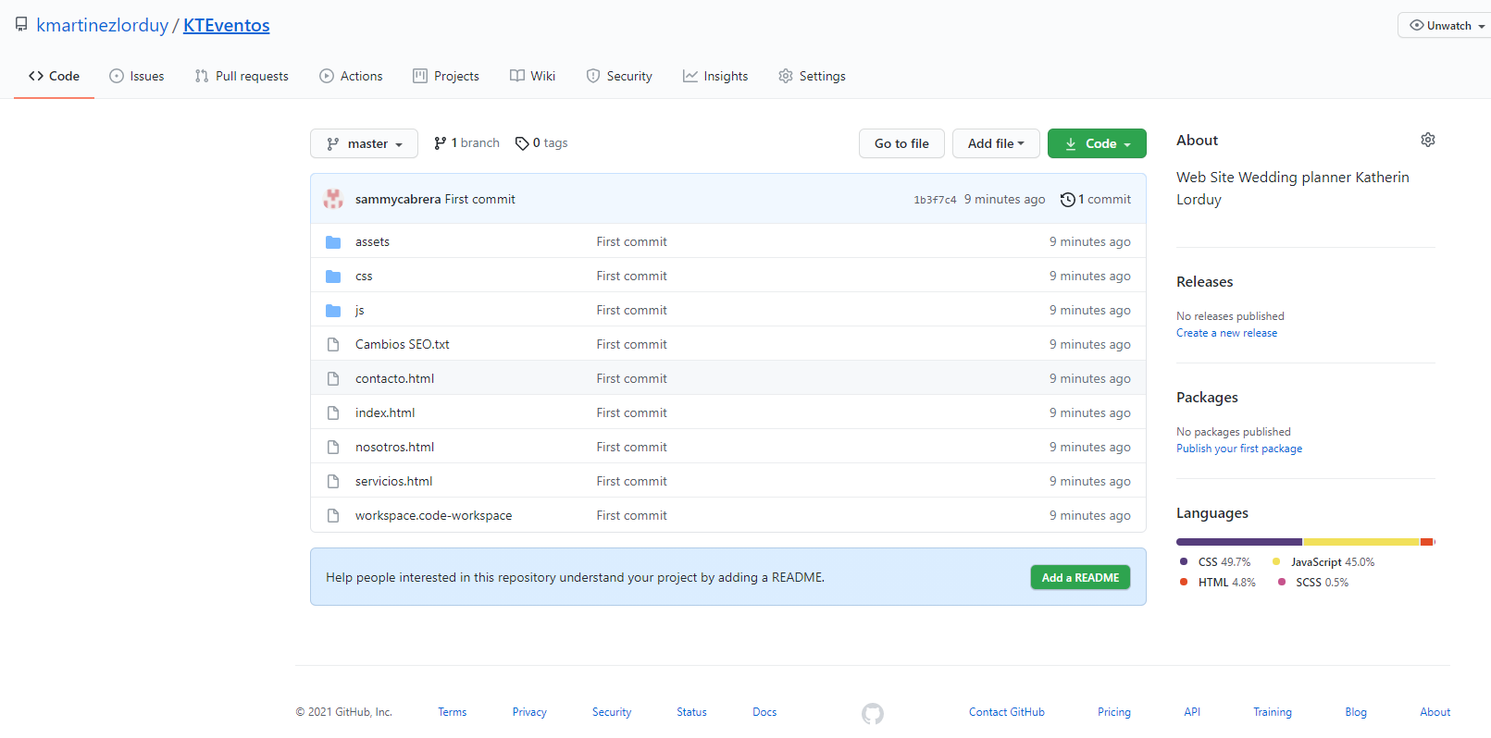

Sammy@SCABRERA-LENOVO MINGW64 /f/git/github/kmartinezlorduy/KTEventos (master)

$ git push --set-upstream origin master

Fatal: HttpRequestException encountered.

Username for 'https://github.com': martinezlorduy@gmail.com

Branch master set up to track remote branch master from origin.

Everything up-to-date



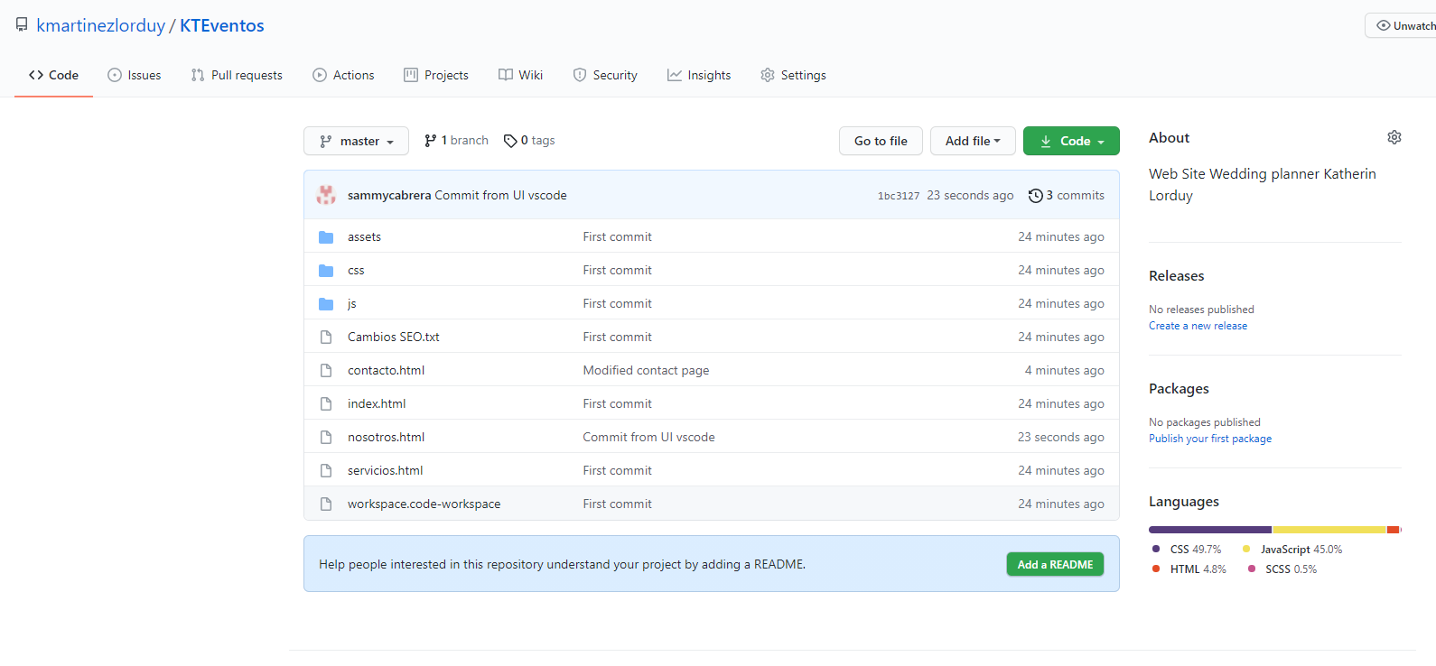

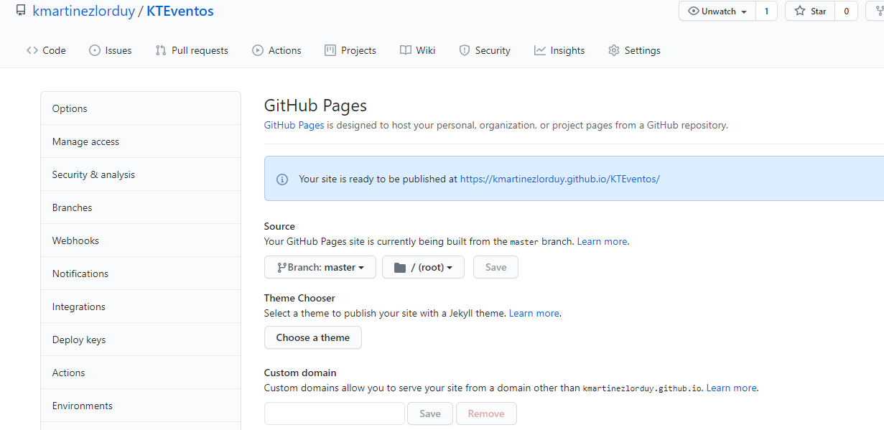

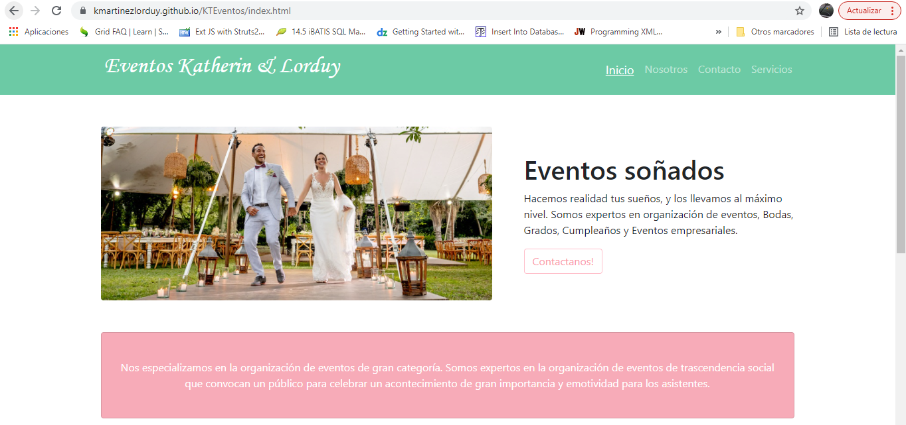

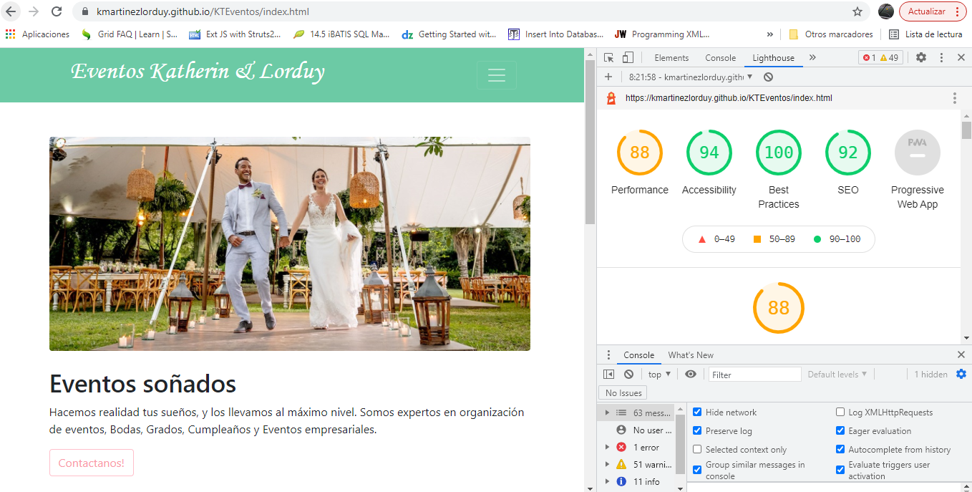

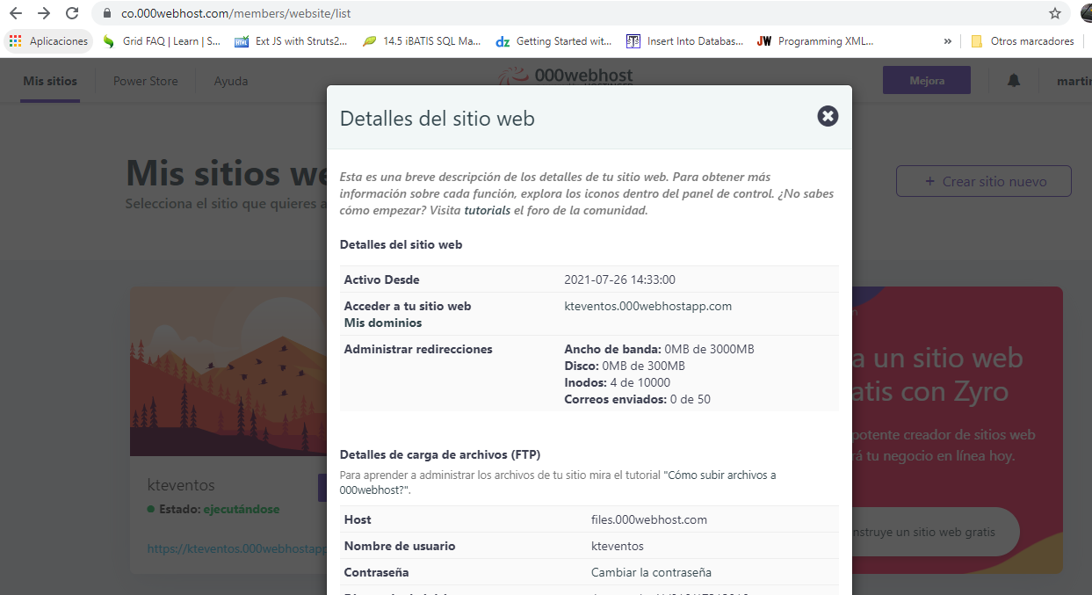

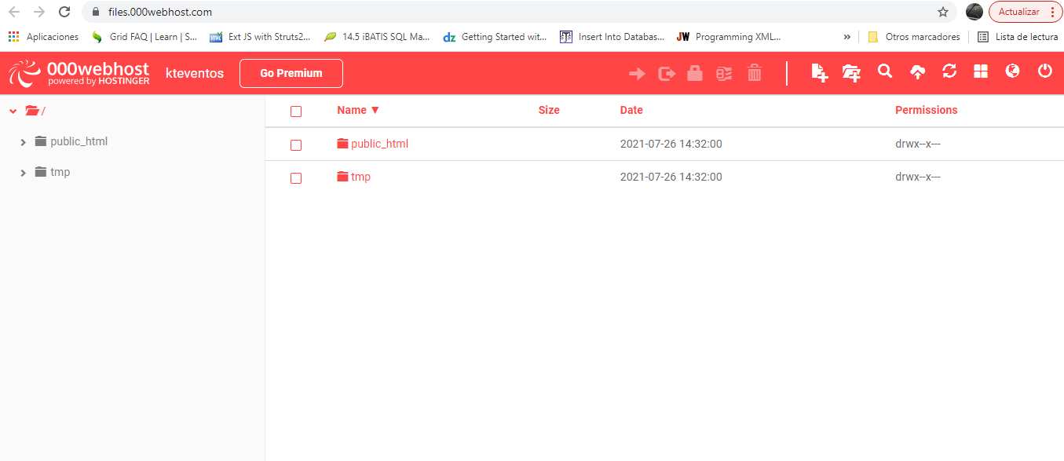

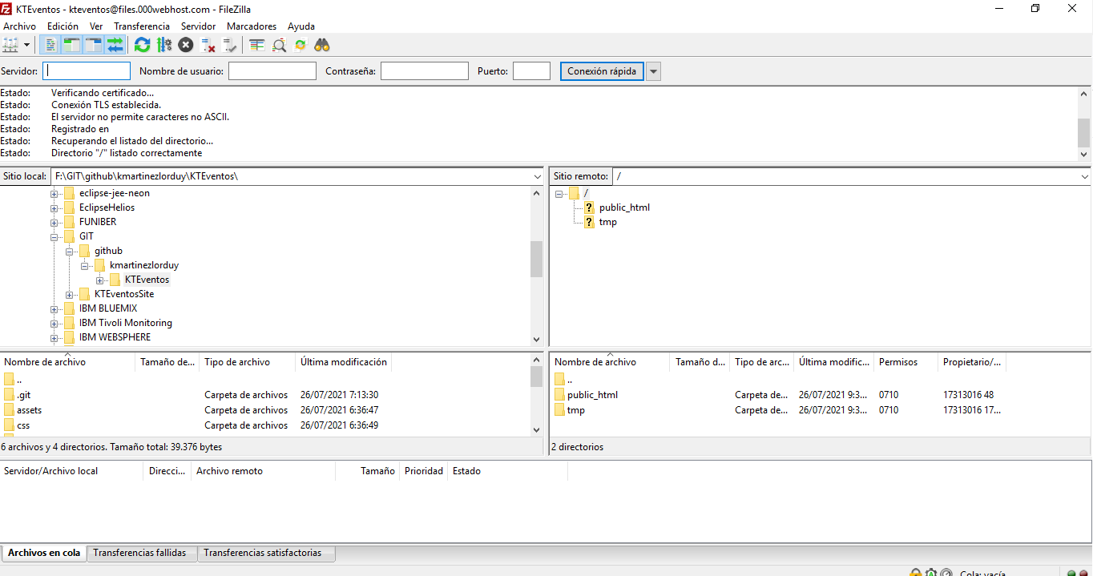

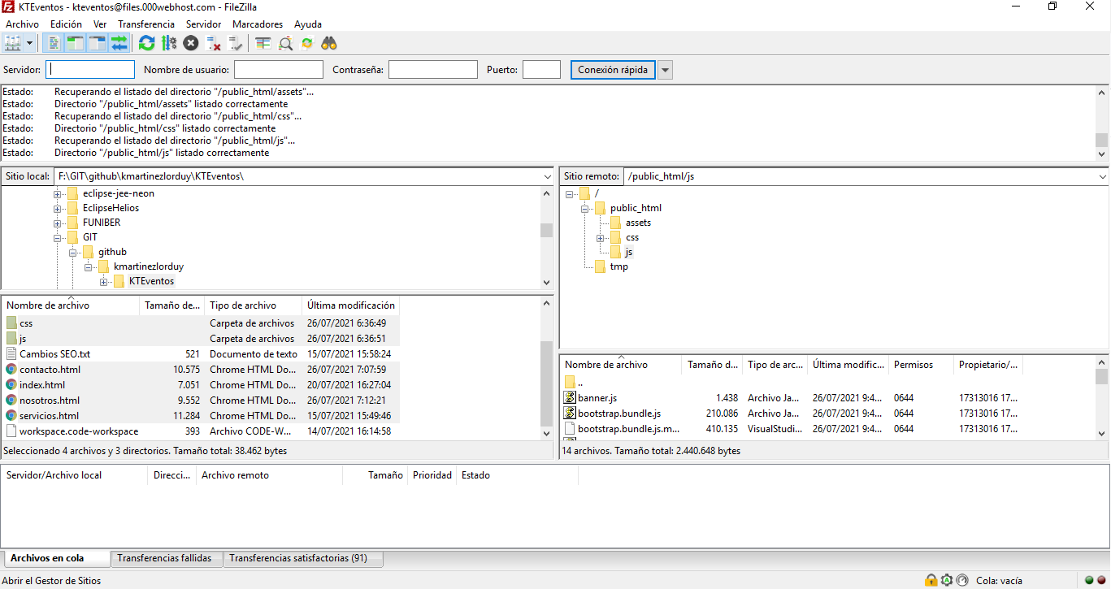

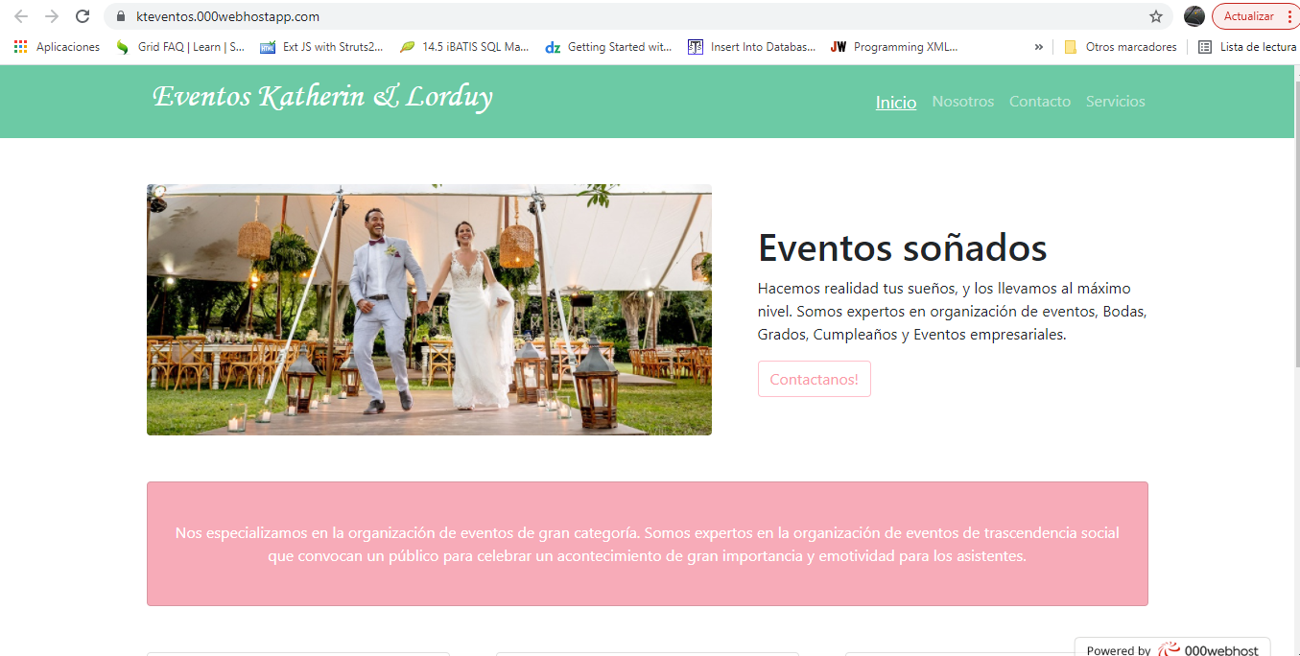

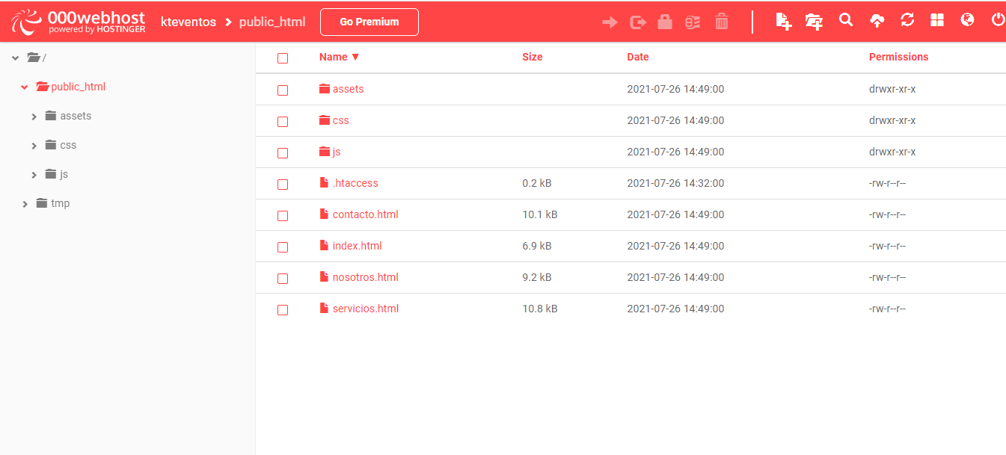

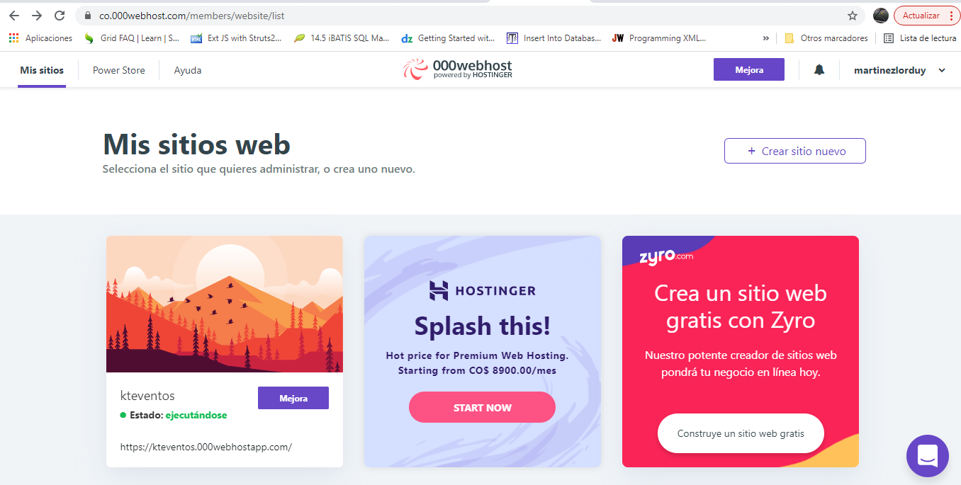

Windows PowerShell

Copyright (C) Microsoft Corporation. Todos los derechos reservados.

PS F:\GIT\github\kmartinezlorduy\KTEventos> npm run watch-css

> kteventos@1.0.0 watch-css F:\GIT\github\kmartinezlorduy\KTEventos

> nodemon -e scss -x "npm run build-css"

[nodemon] 2.0.12

[nodemon] to restart at any time, enter `rs`

[nodemon] watching path(s): *.*

[nodemon] watching extensions: scss

[nodemon] starting `npm run build-css`

> kteventos@1.0.0 build-css F:\GIT\github\kmartinezlorduy\KTEventos

> node-sass --include-path scss css/sass/estilos.scss css/estilos.css

Rendering Complete, saving .css file...

Wrote CSS to F:\GIT\github\kmartinezlorduy\KTEventos\css\estilos.css

[nodemon] clean exit - waiting for changes before restart

Windows PowerShell

Copyright (C) Microsoft Corporation. Todos los derechos reservados.

PS F:\GIT\github\kmartinezlorduy\KTEventos> npm run watch-css

> kteventos@1.0.0 watch-css F:\GIT\github\kmartinezlorduy\KTEventos

> nodemon -e scss -x "npm run build-css"

[nodemon] 2.0.12

[nodemon] to restart at any time, enter `rs`

[nodemon] watching path(s): *.*

[nodemon] watching extensions: scss

[nodemon] starting `npm run build-css`

> kteventos@1.0.0 build-css F:\GIT\github\kmartinezlorduy\KTEventos

> node-sass --include-path scss css/sass/estilos.scss css/estilos.css

Rendering Complete, saving .css file...

Wrote CSS to F:\GIT\github\kmartinezlorduy\KTEventos\css\estilos.css

[nodemon] clean exit - waiting for changes before restart